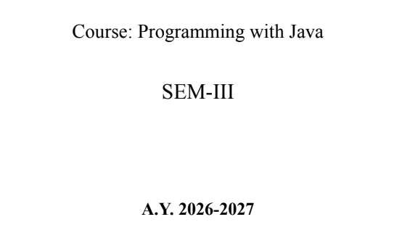

Name: Bhoomi Vijayvargiya
PRN: 25070122062
Batch: A2

ASSIGNMENT No : 1
TITLE :Develop an application based on Java environment setup, JDK/JRE/JVM, variables, methods
and constructors. and demonstrate the implementation of the concepts through suitable examples.
Problem Statement
Develop an application based on Java environment setup, JDK/JRE/JVM, variables, methods and
constructors. and demonstrate the implementation of the concepts through suitable examples.

Learning Objectives
Understand the theoretical concepts, implement them in Java programs, analyze outputs, and apply
the concepts to solve practical programming problems.

Theory
Java environment setup, JDK/JRE/JVM, variables, methods and constructors. forms an important
component of Java programming. Students should understand the underlying concepts, architecture,
advantages, use cases, and implementation methodology. The exercise should focus on
understanding the design principles, coding practices, execution flow, and practical applications of
these concepts in software development. Detailed study should include syntax, APIs, execution
process, and real-world applications.
Output Screenshot
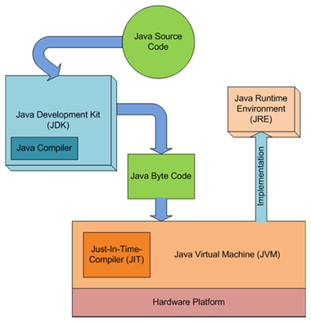
Conclusion
This application demonstrates how the JDK, JVM, JRE compile and run code.
It showcase efficient memory management by using constructors to safely initialize objects, variables, to store data in specific memory areas, and methods to process logic cleanly.

Questions
- Explain the main concept used in Java environment setup, variables and methods.
Answer: Java Environment Setup: Install Java Development Kit (JDK), set the PATH variable, compile using javac, and run using java.
Variables: Used to store data in memory. Example: int age = 20;
Methods: A block of code that performs a specific task and can be reused. Example:
Public static void greet() {
System.out.println(“Hello”);
}
- What are the advantages of using Java variables and methods?
Answer: Advantages of Variables:
- Store data efficiently.
- Make programs easy to read and update.
- Reduce repetition of values.
Advantages of Methods:
- Reuse code.
- Improve readability.
- Make programs easier to debug and maintain.
- How can this implementation be improved?
Answer: Use meaningful variable and methods names.
- Follow proper coding standards.
- Reuse methods instead of repeating code.
- Add comments for better understanding.
- Handle errors using exception handling.
- What are the real-world applications?
Answer: Java variables and methods are used in:
- Banking systems: Manage customer accounts and transactions.
- E-commerce applications: Store product and customer information.
- Mobile apps: Develop Android applications.
- Hospital Management Systems: Manage patient and doctor records.
- Student Management Systems: Store student and results.

